Sprint 3 Report

Receipt Manager
The Receipt Managers
11/18/25

• Actions to stop doing:

- Not preparing our tasks for best integration. For example there was a task that required changing data on the webstore, while another task was working on changing what is intiitially uploaded. We should have first made a smaller task that could be done quickly that defined what the final payload of both of these would be so we could work towards the same thing without changing things in different places.
- Our Scrum meetings are longer then the 15 minutes needed, Some times our standup meetings are more than just the standups, and the work we do could just be completed during a sprint planning meeting. The meetings are blocked out for a reason and keeping those time constraints in mind would benefit our workflow.

• Actions to start doing:
- Detailed Source Control History. Our group would like to enhance our usage of GitHub source control by establishing clear standards. Through these standards, we want to enhance our source control workflow to allow for things like more detailed commit messages and thorough pull-request reviews.
- Documentation Standards. Our group wants to set clear standards for documentation moving forward to ensure our code base's readability. Through setting standards, we hope to achieve faster development and clearer communication, allowing for fewer situations where we need to reach out to team members for clarification on code behavior and intent.
- Testing Standards. Our group is working to implement proper testing standards to ensure that our development of tests is more streamlined. The standards will include requirements for things such as minimum code coverage percentages and patterns for writing and executing tests. The testing standards will allow us to improve the reliability of our program and reduce our technical debt, leading to more quality development.
• Actions to keep doing:
- Showing up to daily standup meetings on time. This is critical because standups are a way for our group to clear up any problems that may have arisen while working independently.
- Documenting the code when committing new code to our project branches. Keep the same quality of documentation to keep our code readable and maintainable.
- Supporting each other with resources regarding issues that are discussed during the meetings. Collaboration is key when running into roadblocks, as you can see how someone else reasons about the same problem.
• Work completed/not completed: This is a list of the user stories that were completed
during the previous sprint, and a list of the user stories not completed during this sprint
(but which were part of this sprint, and were in the sprint plan).
Completed:
- Sprint 2 - User Story 2: As a customer, I want to see all the receipts I have uploaded so I can verify my past physical receipts [12 points].
- {1} As a customer, I want the app to scan my receipt image and extract key information like store name, total, and date so I can easily track my information [11 points]
- Define a data model for OCR-like fields and types (of data). [1]
  - Should have a sheet-like table look, with overarching headers like stores and dates being top-level, with smaller information like items lower than the store. EX:
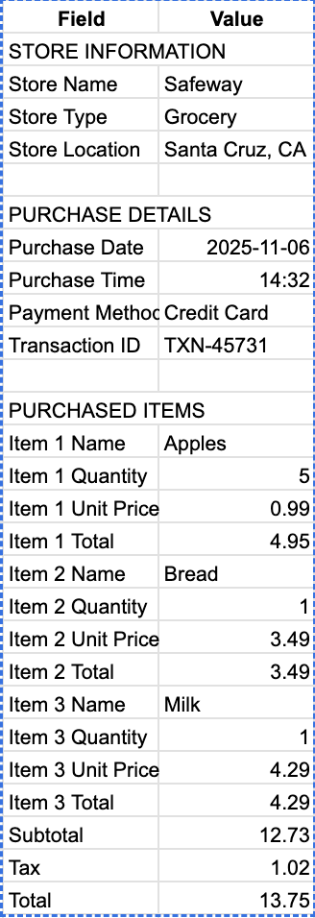
- Integrate on-device text recognition (VisionKit or VNRecognizrTextRequest)[3]
- Build parsing rules like pulling store name, date, subtotal, item names, and price[3]
- Implement a button for rescanning if extrapolation didn’t quite work as intended[1]
- Upload stored information to the Firebase database attached to the receipt and user [3]
  - Most likely will be stored as json data and will need to be translated to fit the database versus the UI view
- {2} As a customer, I want to edit the extracted receipt details so I can correct any scanning errors. [10 points]
- Build an “Edit Receipt” Screen that is prefilled from extracted text before uploading online [3 Points]
- Be able to edit receipt data that is already uploaded online, and see changes reflected in the database [3 Points]
- Track metadata (last edit) and log the information tied to the user’s profile [2 Points]
- {3} As a customer, I want to be able to take multiple photos for a single receipt, so I can scan longer receipts. [5 points]
- Button for multiple photos, or default multiple photos and just choose when to scan image. [2 points]
3. Data from each receipt congregated into one table [1 point]
Not completed:
- {3} As a customer, I want to be able to take multiple photos for a single receipt, so I can scan longer receipts. [5 points]
- Expand library upload to choose multiple photos from the library [2 points]
  - Order the photos to include top and then bottom photo

• Work completion rate: This section should report the following: total number of user
stories completed during the prior sprint. Total number of estimated ideal work hours
completed during the prior sprint. Total number of days during the prior sprint. For the
previous sprint, the user stories/day and ideal work hours/day figures should be reported.
For sprints past the first sprint, this section should also provide the average user
stories/day and average ideal work hours/day figures computed across all sprints to date.
The final sprint burnup chart for the previous sprint should be available for viewing in the
lab and an email of this chart sent to the TA/prof.
- Total user stories completed: 3
- Total estimated ideal work hours completed: 35
- Total sprint duration: 10 days
- User stories per day: 3 stories ÷ 10 days = 0.3 stories/day
- Ideal work hours per day: 40 hours ÷ 10 days = 3.5 ideal work hours/day
- Average user stories/day: 0.2 stories/day
- Average Ideal workhours per day: 0.375 workhours/day
SPRINT BURNUP CHART
